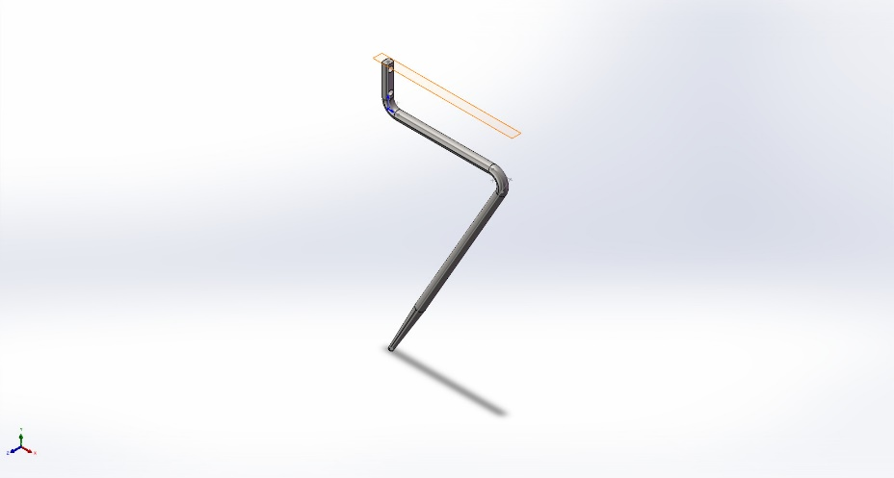
  Simulation of blenderaugerlong
  Date: Sunday, January 4, 2026
  Designer: Solidworks
  Study name: Blade analysis long
  Analysis type: Static
  Table of Contents
  Description 1
  Assumptions 2
  Model Information 2
  Study Properties 3
  Units 3
  Material Properties 4
  Loads and Fixtures 4
  Connector Definitions 5
  Interaction Information 5
  Mesh information 6
  Sensor Details 7
  Resultant Forces 7
  Beams 7
  Study Results 8
  Conclusion 10

Description
No Data

Assumptions

Model Information

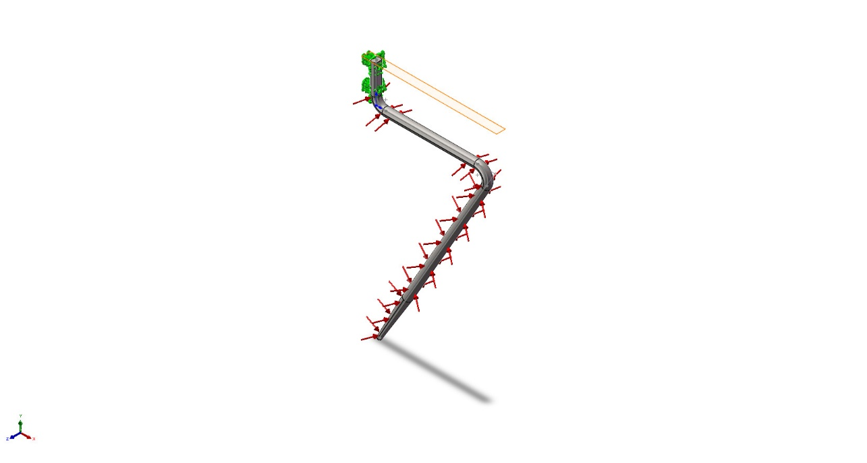
Model name: blenderaugerlong
Current Configuration: 默认
Solid Bodies
Document Name and Reference | Treated As | Volumetric Properties | Document Path/Date Modified
Split Line1  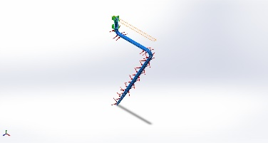 | Solid Body | Mass:0.137864 kg  Volume:1.7233e-05 m^3  Density:8,000 kg/m^3  Weight:1.35107 N | C:\Users\User01\Desktop\vffs\design\design\blenderaugerlong.SLDPRT  Jan 4 01:27:30 2026

Study Properties
Study name | Blade analysis long
Analysis type | Static
Mesh type | Solid Mesh
Thermal Effect: | On
Thermal option | Include temperature loads
Zero strain temperature | 298 Kelvin
Include fluid pressure effects from SOLIDWORKS Flow Simulation | Off
Solver type | Automatic
Inplane Effect: | Off
Soft Spring: | Off
Inertial Relief: | Off
Incompatible bonding options | Automatic
Large displacement | Off
Compute free body forces | On
Friction | Off
Use Adaptive Method: | Off
Result folder | SOLIDWORKS document (C:\Users\User01\Desktop\vffs\design\design)

Units
Unit system: | SI (MKS)
Length/Displacement | mm
Temperature | Kelvin
Angular velocity | Rad/sec
Pressure/Stress | N/m^2

Material Properties
Model Reference | Properties | Components
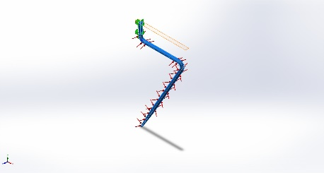 |  | SolidBody 2(Split Line1)(blenderaugerlong)
  Name: | AISI 304
  Model type: | Linear Elastic Isotropic
  Default failure criterion: | Max von Mises Stress
  Yield strength: | 2.06807e+08 N/m^2
  Tensile strength: | 5.17017e+08 N/m^2
  Elastic modulus: | 1.9e+11 N/m^2
  Poisson's ratio: | 0.29
  Mass density: | 8,000 kg/m^3
  Shear modulus: | 7.5e+10 N/m^2
  Thermal expansion coefficient: | 1.8e-05 /Kelvin
Curve Data:N/A

Loads and Fixtures
Fixture name | Fixture Image | Fixture Details
Fixed-1 | 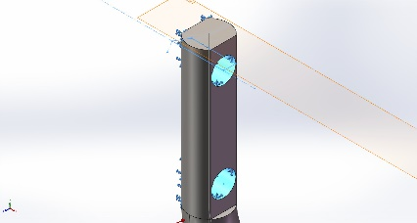
  Entities: | 3 face(s)
  Type: | Fixed Geometry
Resultant Forces
Components | X | Y | Z | Resultant
Reaction force(N) | -1.97617 | -2.95572 | 0.000421062 | 3.55549
Reaction Moment(N.m) | 0 | 0 | 0 | 0

Load name | Load Image | Load Details
Pressure-1 | 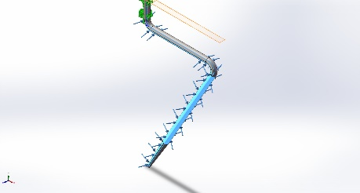
  Entities: | 5 face(s)
  Type: | Normal to selected face
  Value: | 4,000
  Units: | N/m^2
  Phase Angle: | 0
  Units: | deg

Connector Definitions
No Data

Interaction Information
No Data

Mesh information
Mesh type | Solid Mesh
Mesher Used: | Blended curvature-based mesh
Jacobian points for High quality mesh | 16 Points
Maximum element size | 1.74415 mm
Minimum element size | 0.581377 mm
Mesh Quality | High

Mesh information - Details
Total Nodes | 43284
Total Elements | 27080
Maximum Aspect Ratio | 13.478
% of elements with Aspect Ratio < 3 | 99.7
Percentage of elements with Aspect Ratio > 10 | 0.0222
Percentage of distorted elements | 0
Time to complete mesh(hh;mm;ss): | 00:00:01
Computer name:

Mesh Quality Plots
Name | Type | Min | Max
Quality1 | Mesh | - | -
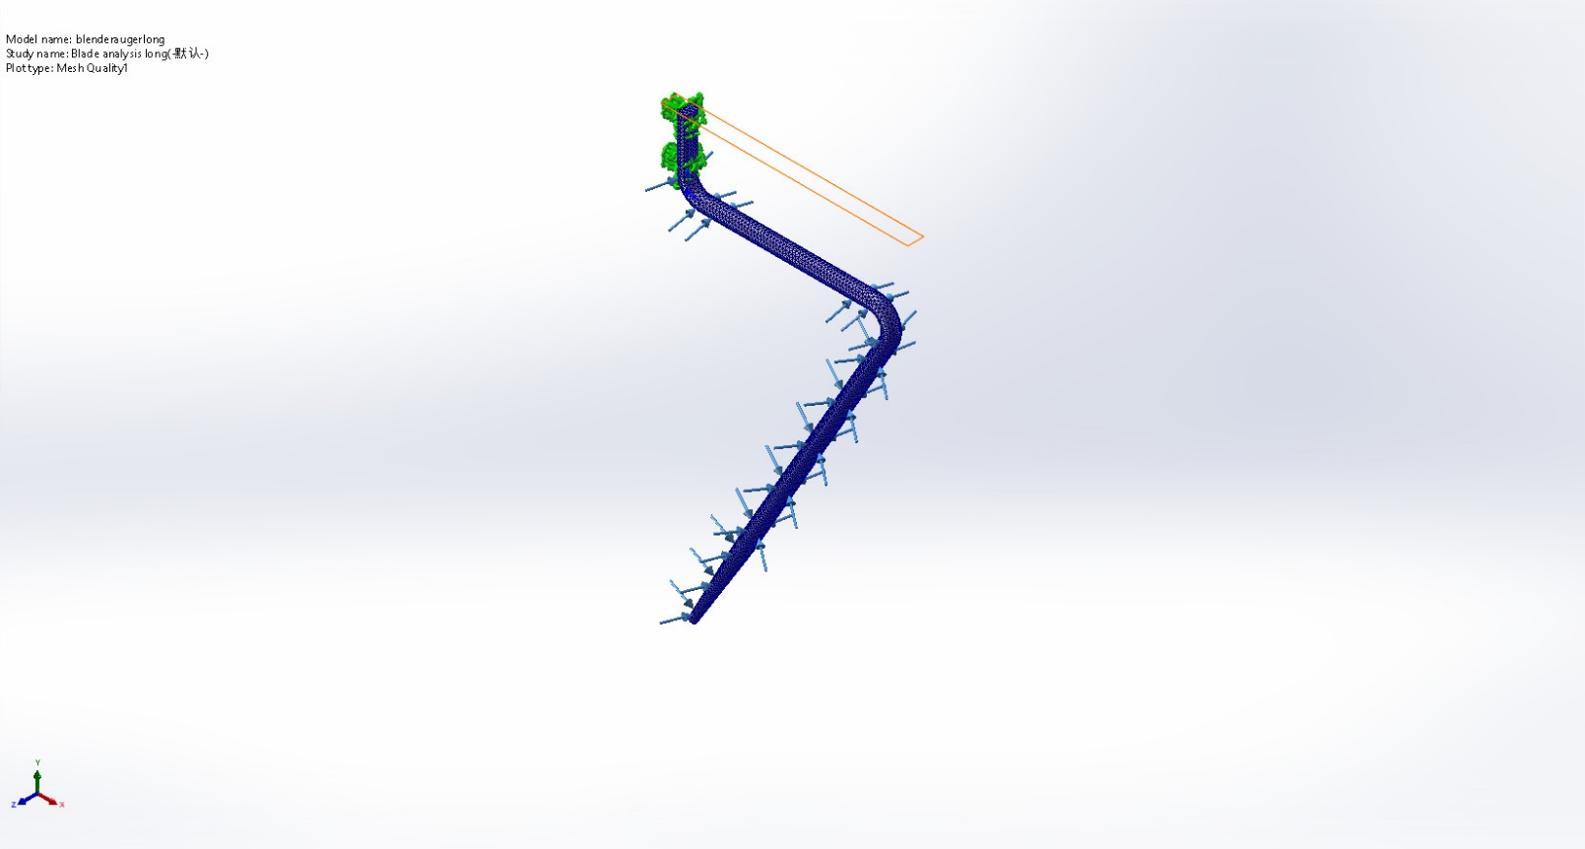
blenderaugerlong-Blade analysis long-Quality-Quality1

Sensor Details
No Data

Resultant Forces

Reaction forces
Selection set | Units | Sum X | Sum Y | Sum Z | Resultant
Entire Model | N | -1.97617 | -2.95572 | 0.000421062 | 3.55549

Reaction Moments
Selection set | Units | Sum X | Sum Y | Sum Z | Resultant
Entire Model | N.m | 0 | 0 | 0 | 0

Free body forces
Selection set | Units | Sum X | Sum Y | Sum Z | Resultant
Entire Model | N | 0.00203958 | 0.00999769 | -0.00583105 | 0.0117522

Free body moments
Selection set | Units | Sum X | Sum Y | Sum Z | Resultant
Entire Model | N.m | 0 | 0 | 0 | 1e-33

Beams
No Data

Study Results

Name | Type | Min | Max
Stress1 | VON: von Mises Stress | 1.453e-01N/m^2  Node: 42507 | 1.163e+07N/m^2  Node: 41507
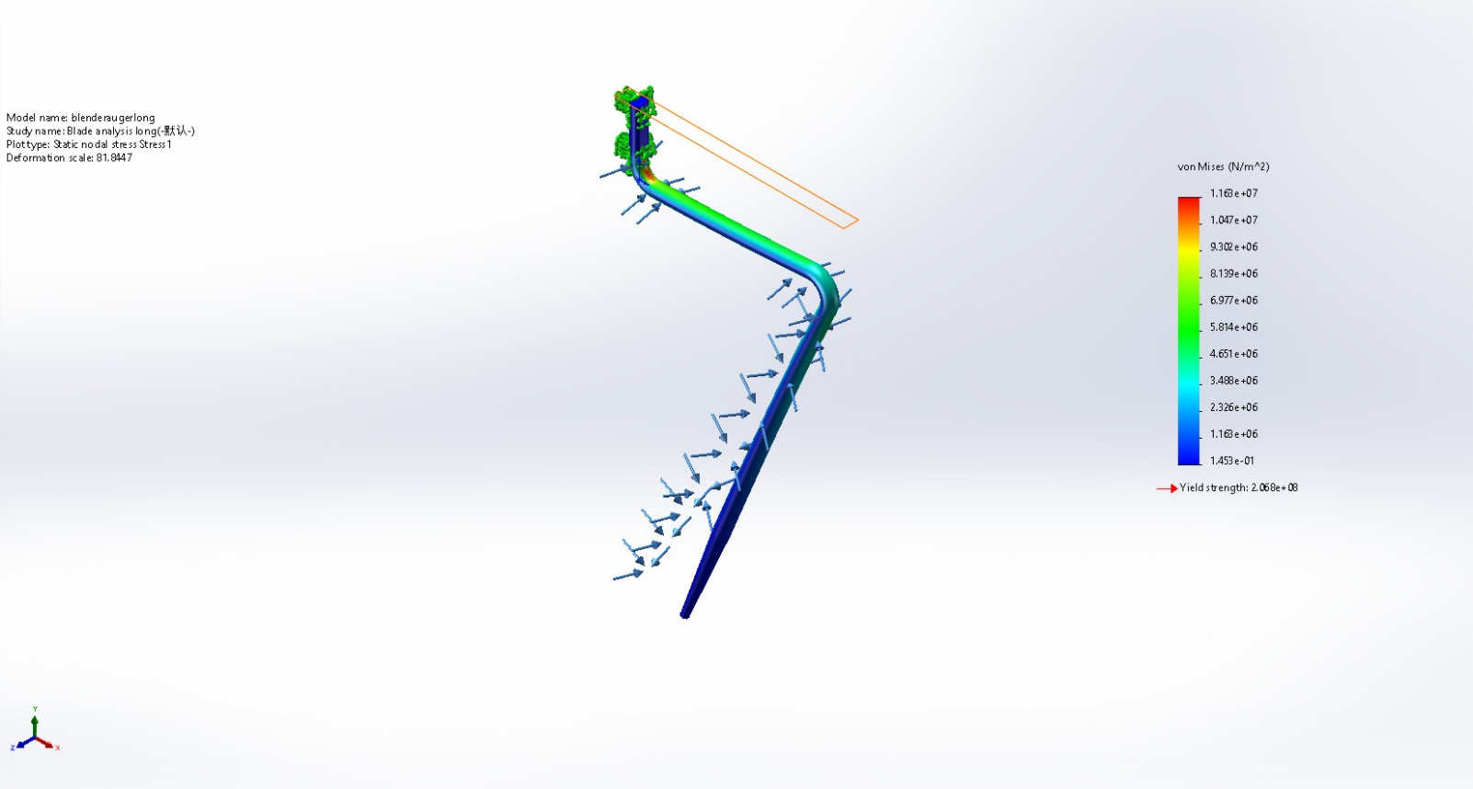
blenderaugerlong-Blade analysis long-Stress-Stress1

Name | Type | Min | Max
Displacement1 | URES: Resultant Displacement | 0.000e+00mm  Node: 6 | 3.127e-01mm  Node: 1115
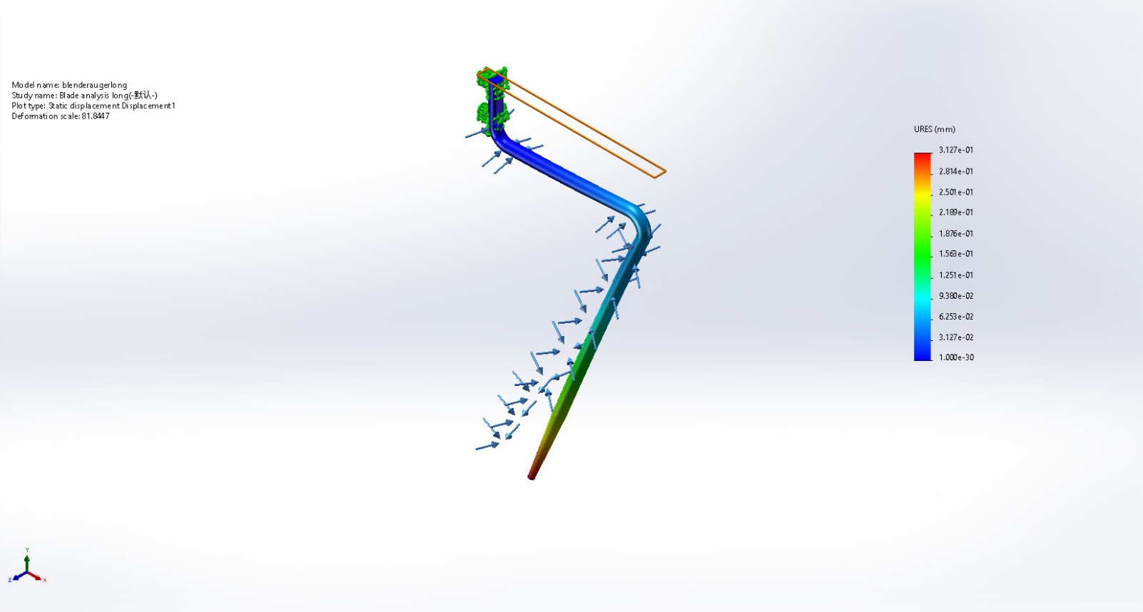
blenderaugerlong-Blade analysis long-Displacement-Displacement1

Name | Type | Min | Max
Strain1 | ESTRN: Equivalent Strain | 8.134e-12  Element: 20556 | 5.196e-05  Element: 26395
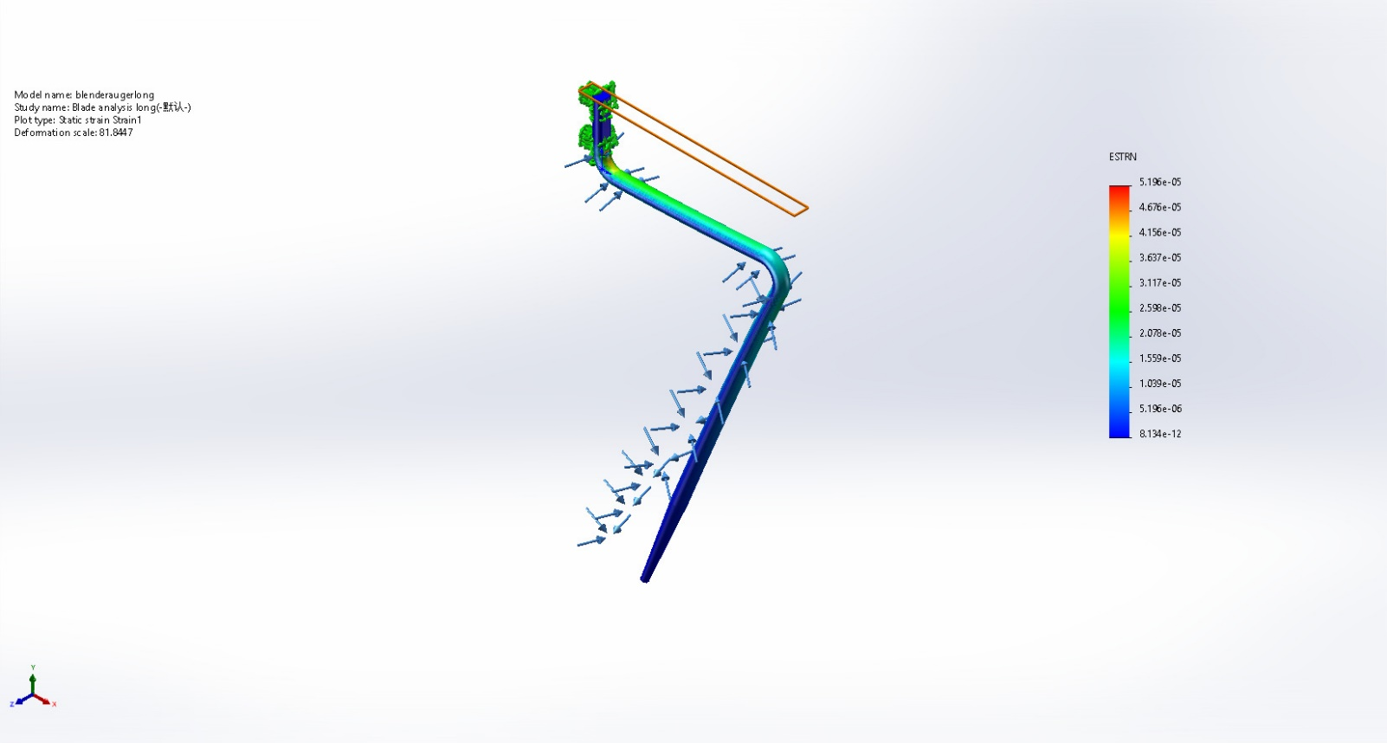
blenderaugerlong-Blade analysis long-Strain-Strain1

Name | Type | Min | Max
Factor of Safety1 | Max von Mises Stress | 1.779e+01  Node: 41507 | 1.424e+09  Node: 42507
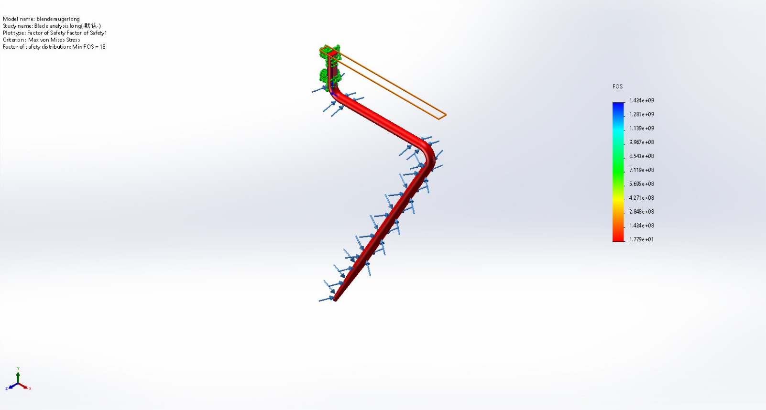
blenderaugerlong-Blade analysis long-Factor of Safety-Factor of Safety1

Conclusion

